Asa se interogheaza in rethink si asta e structura datelor.

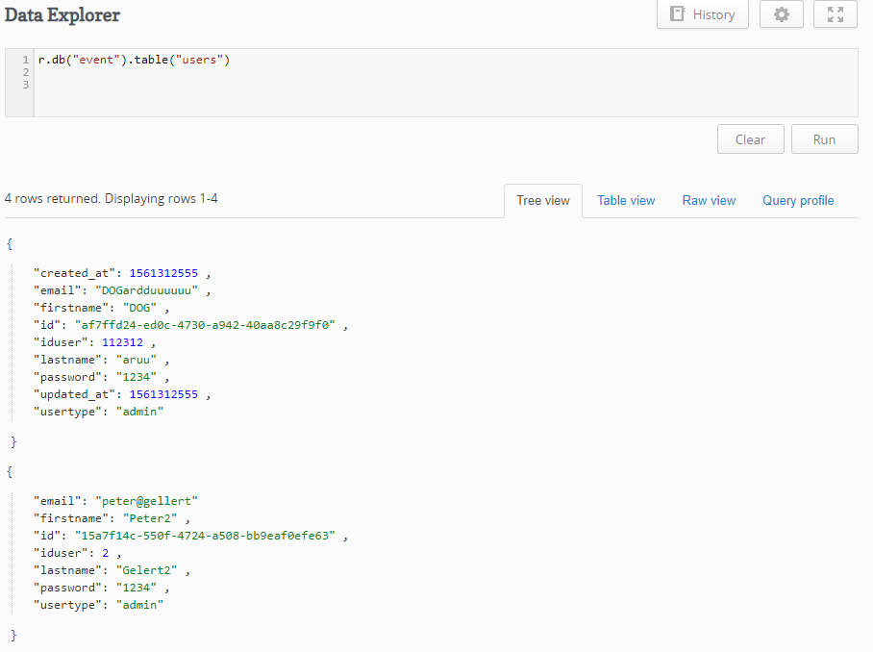

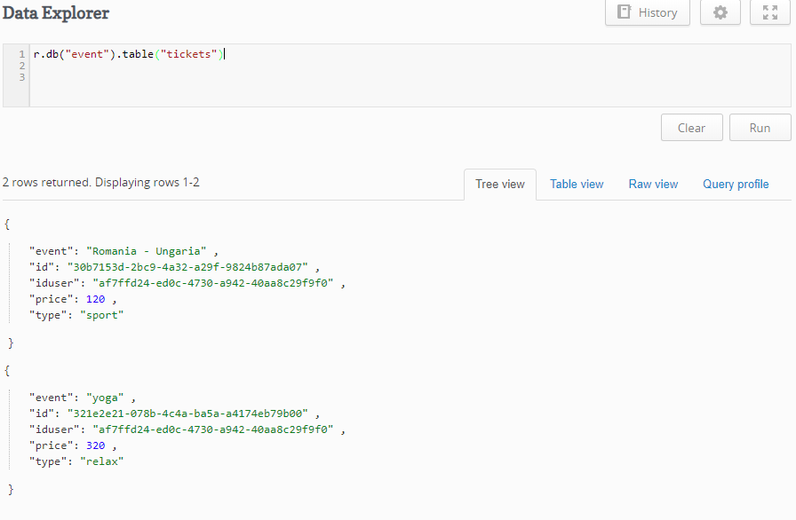

Asa se adauga:

r.db("event").table("tickets").insert({

"type": "relax",

"price" : 320,

"event": "yoga",

"iduser" : "af7ffd24-ed0c-4730-a942-40aa8c29f9f0"

})